AgriVision AI: Agricultural Pest Detection and Field Advisory Platform
A College Project Report on Multi-Class Deep Learning Object Detection
and Conversational Agronomic Guidance
――――――――――――――――――――――――――――――
Department of Artificial Intelligence and Data Science
Undergraduate Capstone Project Report
Academic Year: 2025 – 2026
October 2026

2. Abstract
Agricultural insect pests cause substantial crop yield losses worldwide, typically between 20% and 40%. In farming communities, timely identification is hindered because agricultural extension officers cannot visit every farm, pests are small and camouflaged in foliage, and closely related species look very similar. As a result, farmers often spray broad-spectrum pesticides preventatively, which increases production costs, eliminates beneficial insects, and contaminates soils.
In this project, we developed AgriVision AI, an end-to-end web system that detects crop pests using a fine-tuned YOLO11n detector and provides field management guidance. We trained on the IP102 dataset (18,981 images, 22,289 bounding boxes, across 97 detection-annotated classes out of 102 benchmark species). Pascal VOC XML annotations were converted into normalized YOLO labels, and an official test set of 3,798 images was held out. We also fixed a critical color-inversion bug in the legacy image loading pipeline where RGB arrays were mistakenly inverted into BGR, which restored proper color delivery and raised confidence on targets like the rice leaf roller from 63.7% to 81.7%.
Trained over 50 epochs on an NVIDIA GPU, our baseline model (best.pt, 5.6 MB) achieves 54.48% mAP@0.50, 34.79% mAP@0.50:0.95, 50.97% precision, and 58.98% recall on the held-out test set with a latency of 45.8 ms. We built a FastAPI backend and React frontend with an interactive canvas and camera capture. To assist farmers after detection, we integrated 'Kural', a conversational assistant using Retrieval-Augmented Generation (RAG) over ICAR and TNAU agronomic guidelines. Kural supports English, Tamil, and Hindi, provides 4-tier Integrated Pest Management (IPM) advisories, and enforces safety rules refusing chemical dosage recipes.
3. Introduction
Agriculture is the primary livelihood source for hundreds of millions of people, particularly in India where over 45% of the workforce is engaged in farming. Insect pests represent a constant risk to crop health across staples like rice, wheat, corn, and cotton. Early detection is crucial: when caught in early larval stages, mechanical or biological measures can keep pest populations below the Economic Threshold Level (ETL). If missed, populations surge, forcing farmers into expensive emergency chemical spraying.
Conventional field scouting depends on manual walking surveys, which are labor-intensive, slow, and subjective. Computer vision offers an effective alternative. While image classification models can indicate whether an insect is present somewhere in an image, they cannot locate multiple targets, estimate count density, or handle cases where an insect occupies only a small part of a high-resolution field photo.
AgriVision AI was built to deliver a fast, edge-capable object detection pipeline that performs real-time pest localization and connects it directly to agronomic advice. We focused on building a dependable system: correcting image preprocessing defects, using a compact YOLO11n model that runs efficiently on standard hardware, and grounding conversational advice in verified agricultural publications.
4. Problem Statement and Objectives
4.1 Problem Statement
Building an autonomous pest detection system presents several practical challenges:
- Morphological Variation: Insects vary significantly across life stages (larva, pupa, adult), with colors and shapes differing even within one species.
- Visual Mimicry: Sibling species such as the cabbage army worm and beet army worm look almost identical in the larval stage, causing misclassification.
- Field Clutter: Natural photographs feature wind blur, changing sunlight, shadows, and insects partly hidden behind leaves and stems.
- Software Pipeline Defects: Mismatch between RGB and BGR conventions in image libraries can silently invert color channels, degrading neural feature maps.
- Unclear Field Next Steps: Raw bounding boxes with probabilities do not tell farmers how to respond under Integrated Pest Management guidelines.
4.2 Project Objectives
Our primary project objectives were:
- 1. Dataset Processing: Convert the IP102 dataset from Pascal VOC XML into normalized YOLO format with coordinate clamping and split isolation.
- 2. Deep Learning Training: Fine-tune a lightweight YOLO11n detector on IP102 to achieve sub-50 ms inference latency and dependable localization.
- 3. Preprocessing Fixes: Build an image service that corrects EXIF orientation, alpha compositing, and color order to prevent channel inversion errors.
- 4. Web Platform Deployment: Develop a FastAPI REST backend and a React 18 frontend with an interactive canvas, camera capture, and dual cloud/local persistence.
- 5. Agronomic AI Assistant: Build 'Kural', a conversational assistant using RAG over ICAR and TNAU extension guidelines with chemical safety guardrails.
5. Dataset Description
We used the IP102 dataset (Wu et al., CVPR 2019), an established benchmark for agricultural pest recognition. Before running any data transformations, we programmatically inspected the dataset files on disk (reports/dataset_inspect.md). Table 1 outlines the measured dataset metrics.
Metric | Disk Value | Description / Meaning
Total Images | 18,981 | Real-world field photos collected across diverse crops.
Annotated Bounding Boxes | 22,289 | Spatial coordinates marking insect locations in detection photos.
Detection Classes Present | 97 Classes | 97 of the 102 benchmark classes have ground-truth bounding boxes in VOC.
Total Taxonomy Classes | 102 Classes | Complete species catalog supported in the platform's knowledge base.
Image Resolutions | 75x75 to 6034x6953 | Median resolution is 468x380 px; covers small crops to macro photos.
Small Bounding Boxes | 1,599 boxes | Relative box area < 0.05 (less than 5% of the total photo area).
TrainVal Set | 15,178 images | Partitioned into 85% training (12,901) and 15% validation (2,277) with seed 42.
Official Test Set | 3,798 images | Held-out test partition with 4,444 bounding boxes, used strictly for final evaluation.
Table 1: Structural Parameters of the IP102 Dataset on Disk
5.1 Annotation Conversion and Preprocessing
The IP102 detection annotations were provided in Pascal VOC XML format with pixel coordinates [xmin, ymin, xmax, ymax]. YOLO requires normalized center coordinates [class_id, x_center, y_center, width, height] between 0.0 and 1.0. Our conversion script (prepare_dataset.py) performed the following steps:
- Index Remapping: IP102 classes.txt uses 1-based numbering (1 to 102). We remapped this to 0-based indexing (0 to 101) so class 1 (rice leaf roller) maps to class 0.
- Coordinate Clamping: Source annotations extending beyond image dimensions were clamped via max(0, min(coord, dimension)). One degenerate box with zero area and one corrupt XML file were safely skipped.
- Split Isolation: The 15,178 trainval images were divided into 85% train (12,901) and 15% val (2,277) with seed 42. The 3,798 test images were kept completely untouched.
6. Proposed Deep-Learning Methodology
We selected the single-stage YOLO11 nano (YOLO11n) architecture. Two-stage detectors like Faster R-CNN utilize a separate Region Proposal Network requiring substantial compute and memory (>40M parameters and >150 ms per image), making them difficult to run on resource-constrained field hardware. YOLO11n treats detection as a direct regression task, predicting bounding boxes and class probabilities in a single feed-forward pass with only 2.6 million parameters.
The model is trained using three loss functions:
- Complete IoU (CIoU) Loss: Governs box regression by penalizing overlap error, center-point distance, and aspect ratio discrepancies: L_CIoU = 1 - IoU + (rho^2 / c^2) + alpha * v.
- Distribution Focal Loss (DFL): Models box boundaries as continuous probability distributions over discrete bins, improving localization for blurry or occluded insect edges.
- Binary Cross-Entropy (BCE) with TAL: Computes classification loss using a Task-Aligned Assigner that dynamically pairs ground truth with anchors based on both classification confidence and box overlap.
7. YOLO11n Model and Training
YOLO11n uses a C3k2 convolutional backbone to extract features, an SPPF module at the neck for multi-scale context, and a Path Aggregation Network (PANet) fusing three feature scales (P3 at 80x80 for small insects, P4 at 40x40 for medium targets, and P5 at 20x20 for larger pests). Its anchor-free decoupled head separates classification from box regression.
We fine-tuned the model on an NVIDIA GeForce RTX GPU using the parameters shown in Table 2.
Parameter | Configured Value | Technical Justification / Purpose
Model Backbone | yolo11n.pt | Pretrained weights on COCO, fine-tuned for 102 pest classes.
Image Size (imgsz) | 640 × 640 | Balances spatial detail on small insects with GPU memory requirements.
Batch Size | 8 | Maintains stable gradient updates within available GPU VRAM.
Epochs | 50 | Completed run (pest_training-2), totaling 9,300.97 seconds (~2.58 hours).
Optimizer | SGD (momentum=0.937) | Initial lr0 = 0.01, cosine decay to lrf = 0.01, weight decay = 0.0005.
Warmup | 3.0 epochs | Linear warmup with momentum 0.8 to stabilize initial weights.
Augmentations | HSV, Flips, Mosaic | HSV jitter (h=0.015, s=0.7, v=0.4), random translate and scale, horizontal flips.
Close Mosaic | 10 epochs | Mosaic augmentation deactivated for final 10 epochs (41–50) for clean boundary convergence.
Table 2: Training Hyperparameter Configuration for YOLO11n on IP102

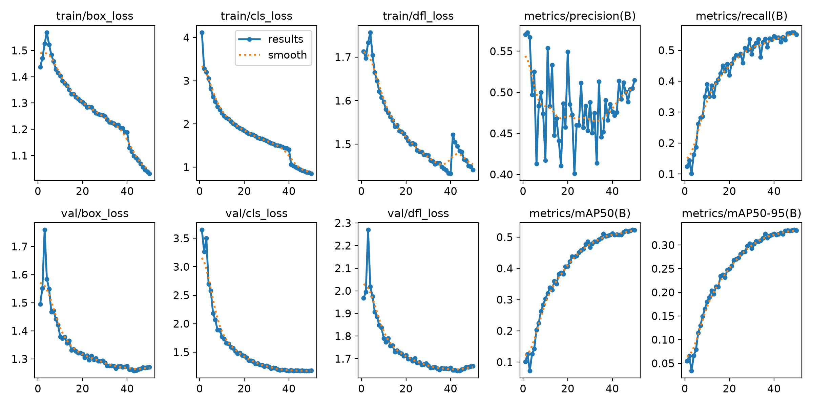
Figure 1: Training and Validation Loss Curves and Metric Progression over 50 Epochs
8. Evaluation and Results
During training, validation metrics improved consistently across 50 epochs. At Epoch 1, the model achieved 57.03% precision, 12.39% recall, and 10.12% mAP@0.50. By Epoch 50, validation reached 51.49% precision, 55.07% recall, 52.25% mAP@0.50, and 33.08% mAP@0.50:0.95, while training classification loss dropped from 4.1187 to 0.8555.
We evaluated the final model (best.pt) on the official held-out test split of 3,798 images (4,444 boxes), comparing it with an experimental 20-epoch class-balanced model. The test results are detailed in Table 3.
Evaluation Metric | Baseline (best.pt) | 20-Epoch Balanced | Difference | Takeaway
mAP@0.50 | 54.48% | 50.47% | -4.01% | Baseline is more accurate across all 102 classes.
mAP@0.50:0.95 | 34.79% | 31.95% | -2.84% | Baseline achieves tighter, more consistent bounding boxes.
Precision | 50.97% | 51.24% | +0.27% | Balanced model exhibits slightly fewer false alarms.
Recall | 58.98% | 51.84% | -7.14% | Baseline detects noticeably more actual pests in the field.
F1-Score | 54.68% | 51.54% | -3.14% | Baseline provides a superior balance between precision and recall.
GPU Latency | 45.8 ms | 51.8 ms | -6.0 ms | Baseline runs faster on our RTX GPU setup.
Table 3: Official Held-Out Test Set Performance Benchmark (3,798 Images, 4,444 Boxes)
Class balancing provided noticeable gains on underrepresented species: Chlumetia transversa improved by +47.0% AP and Dacus dorsalis by +23.4% AP. However, because balancing slightly reduced accuracy on common staple pests like leaf rollers and aphids, the baseline model maintained a 4.01% lead in mAP@0.50 and a 7.14% lead in recall. Therefore, best.pt was retained as the production model.
8.1 Discovery and Fix of the Color Channel Inversion Defect
During testing, we discovered that raw RGB NumPy arrays were being passed directly to model.predict(). Ultralytics assumes NumPy inputs are in OpenCV BGR format and automatically swaps channels (im = im[..., ::-1]), corrupting RGB inputs into BGR. Table 4 demonstrates the impact on benchmark sample ip000000008.jpg (Ground Truth: rice leaf roller).
Pipeline Configuration | Top Prediction | Confidence | False Positives | Diagnosis Outcome
Buggy Pipeline (RGB NumPy Array) | rice leaf roller | 63.7% | 1 (rice leaf caterpillar @ 26%) | Subdued confidence and false alarm.
Corrected Pipeline (Native RGB PIL) | rice leaf roller | 81.7% | 0 (Clean match) | Confidence boosted by +18.0% with zero false alarms.
Table 4: Empirical Impact of the Color Inversion Defect vs. the Corrected Preprocessing Pipeline

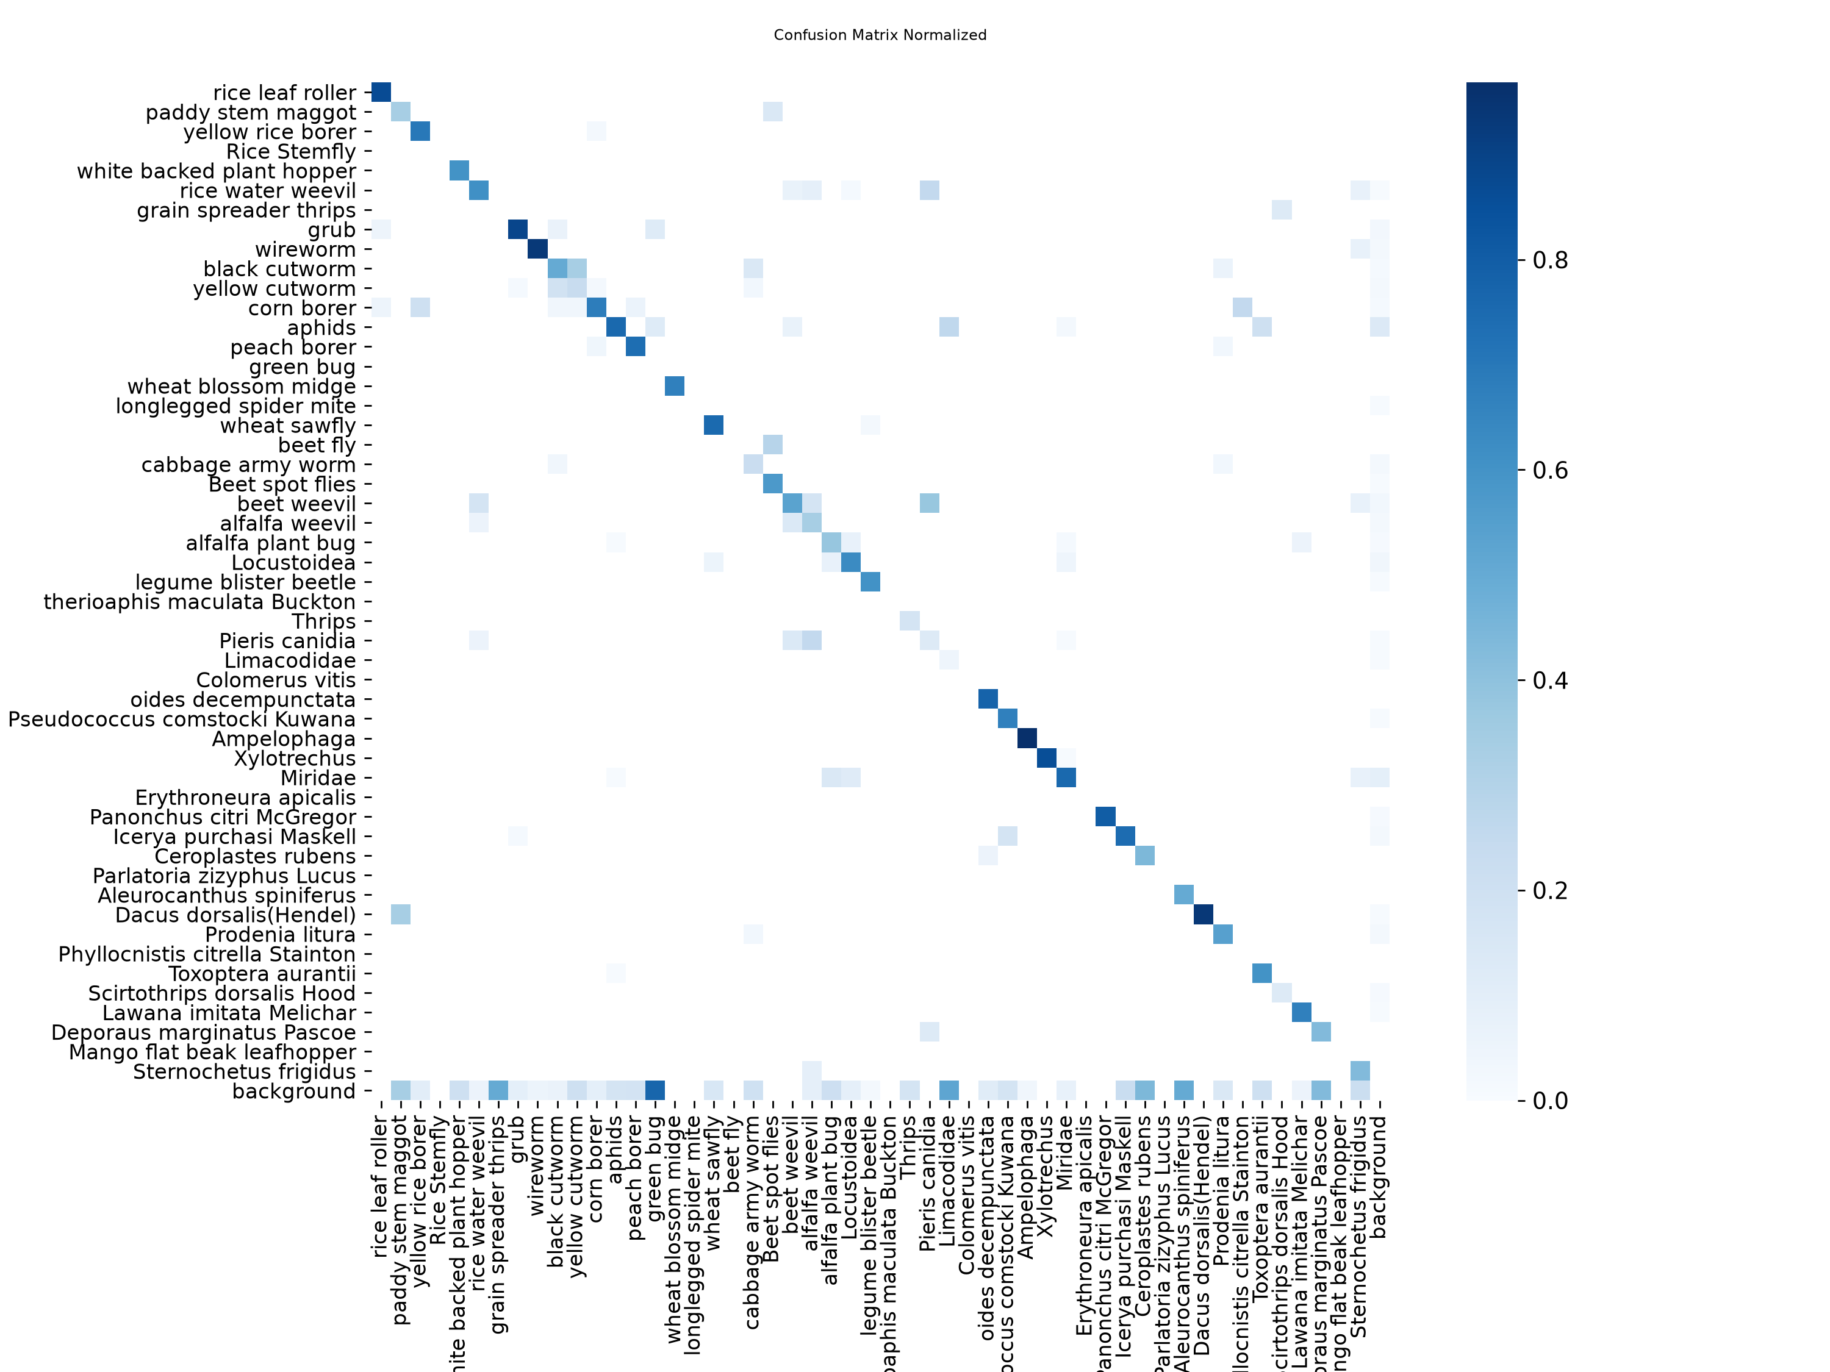
Figure 2: Normalized Confusion Matrix across 102 IP102 Classes
9. System Implementation
We deployed the model as part of a decoupled full-stack web application designed for practical field diagnostics:
- FastAPI Backend (Python 3.11): An asynchronous REST API handles image uploads, runs inference with the loaded YOLO model, and serves structured responses validated with Pydantic v2 schemas.
- React 18 + Vite Frontend: A responsive interface built with TypeScript and Tailwind CSS, featuring drag-and-drop upload and HTML5 camera capture with rear camera selection (facingMode: 'environment').
- Interactive Canvas Viewer: Users can toggle between the raw uploaded photo and the annotated bounding box view, zoom into detected insects, and download the annotated JPEG.
- Calibrated Confidence Badges: Detections are grouped into three clear tiers: High (>= 75%, green), Moderate (50–74%, amber), and Low (< 50%, red), each paired with verification guidance.
- Storage and Persistence: Images are stored on disk in uploads/images and uploads/annotated. Metadata and bounding box arrays are saved to MongoDB Atlas, with automatic fallback to local JSON (uploads/local_history.json) when offline.
- Kural AI Assistant: An integrated assistant grounded in ICAR and TNAU agronomic recommendations using RAG. It handles queries in English, Tamil, and Hindi, provides 4-tier IPM recommendations, and strictly refuses chemical dosage calculations, directing farmers to container labels and local extension officers.
Status of Assistant Fine-Tuning
Note on Fine-Tuning: We prepared and verified fine-tuning datasets (kural_finetune_train.jsonl with 32 pairs and kural_finetune_val.jsonl with 10 pairs). However, fine-tuning of an LLM checkpoint was not performed. The current Kural service operates via prompt grounding and RAG retrieval over the local agronomic catalog.
10. Testing and Discussion
We tested the backend using an automated pytest suite covering endpoints, authentication, image loading, inference, and Kural assistant behavior. All 51 test cases passed in 10.63 seconds, as summarized in Table 5.
Test Module | Count | What Was Tested | Result
test_api.py | 10 | Health checks, model-info, pest listings, history, and diagnosis payloads. | 10/10 Passed
test_auth.py | 3 | Password hashing with bcrypt, JWT token creation, and login/register flows. | 3/3 Passed
test_camera_upload.py | 1 | Ingestion and diagnosis of frames captured from live HTML5 camera. | 1/1 Passed
test_class_mapping.py | 5 | IP102 class lookups, name searches, and ID-to-name mapping integrity. | 5/5 Passed
test_e2e.py | 1 | Complete end-to-end workflow from upload to inference to saved history. | 1/1 Passed
test_history_isolation.py | 1 | Ensures diagnosis records are isolated between different user accounts. | 1/1 Passed
test_image_utils.py | 8 | RGB normalization, RGBA white compositing, EXIF rotation, and corrupt file rejection. | 8/8 Passed
test_inference.py | 4 | Model loading, inference on known test images, and rejection of empty/noise images. | 4/4 Passed
test_kural_assistant.py | 16 | RAG search, English/Tamil/Hindi chat, intent handling, and chemical dosage refusals. | 16/16 Passed
test_multi_detection.py | 2 | Multi-pest scene parsing and structured 4-tier IPM payload generation. | 2/2 Passed
Table 5: Summary of the Automated Pytest Suite (51 Tests Passed in 10.63s)
We also validated model behavior on negative non-pest samples (uniform gray noise and plain foliage photos). The detector correctly produced 0 detections, confirming that our confidence threshold (0.35) and color normalization prevent false detections on uninfected plants.
11. Limitations and Future Improvements
11.1 Limitations
- Visual vs. Biological Reality: The model detects visual surface patterns. It cannot confirm microscopic physical traits or perform genetic identification.
- Foliage Occlusion: Very small pests (<10 px) or insects hidden deep beneath overlapping foliage can be missed.
- Sibling Species Confusion: Insects that look nearly identical in their larval stages (such as cabbage army worm vs. beet army worm) occasionally show cross-class confusion.
- Dataset Coverage: While IP102 lists 102 classes, only 97 classes have bounding box labels in the detection split. The remaining 5 classes cannot be spatially localized.
11.2 Future Improvements
- INT8 Model Quantization: Quantizing the model with TensorRT or TFLite to reduce file size below 2 MB and run under 30 ms on smartphones.
- Local LLM Fine-Tuning: Using our prepared JSONL datasets to fine-tune a small local language model (like Gemma-2-2B or Llama-3-8B) for offline guidance.
- Drone Image Tiling: Using Slicing Aided Hyper Inference (SAHI) to process high-resolution drone photos and generate field-wide pest heatmaps.
- Voice Interface: Adding regional speech-to-text input to help farmers interact with the platform through spoken voice commands.
12. Course Outcome (CO) Mapping
Draft Course Outcome Mapping
Draft Mapping Notice: The official course code and institutional syllabus statements were not available in the project files. The table below is a draft mapping aligned with standard undergraduate Deep Learning course outcomes. Official CO statements from the institution will be required to finalize this section.
CO | Official Course Outcome (Draft) | Related Project Work | Justification
CO1 | Formulate real-world computer vision problems and design deep learning pipelines. | Built an end-to-end multi-class pest detection pipeline from raw field photos to UI display. | Designed full system architecture, image preprocessing, and FastAPI REST endpoints.
CO2 | Perform data engineering, annotation conversion, and augmentation for vision tasks. | Converted 18,981 IP102 images from Pascal VOC XML to YOLO format with boundary clamping. | Implemented coordinate normalization, HSV jitter, random affine scaling, and Mosaic.
CO3 | Implement, analyze, and optimize deep neural network architectures and loss functions. | Fine-tuned YOLO11n on 102 pest classes using CIoU, DFL, and BCE losses over 50 epochs. | Applied C3k2, SPPF, PANet feature fusion, and monitored loss convergence across epochs.
CO4 | Evaluate deep learning models using standard metrics and perform error analysis. | Evaluated baseline and balanced models on 3,798 test images; fixed color channel bug. | Measured precision, recall, mAP@0.50, and mAP@0.50:0.95; verified +18% gain on corrected image.
CO5 | Integrate deep learning outputs with conversational AI and domain knowledge. | Built Kural assistant using RAG over ICAR/TNAU guides with safety guardrails and multi-language support. | Implemented token-weighted knowledge retrieval, prompt grounding, and structured IPM guidance.
CO6 | Deploy vision models on web platforms with automated testing (Partially Mapped). | Created FastAPI backend, React frontend, dual MongoDB/local persistence, and 51 automated tests. | Tested API endpoints, image utils, and inference in pytest. (Quantization left for future).
Table 6: Draft Course Outcome Mapping Through Deep Learning (Subject to Departmental Finalization)
13. Conclusion
In this project, we built and verified AgriVision AI, a practical agricultural pest detection and decision-support web platform. By training a lightweight YOLO11n object detector on the IP102 dataset, our system achieved 54.48% mAP@0.50, 50.97% precision, and 58.98% recall on an official held-out test set of 3,798 field images, while operating at a fast 45.8 ms inference latency. Fixing the color channel inversion bug was a key practical breakthrough, raising confidence on benchmark targets from 63.7% to 81.7% and eliminating false alarms.
We connected this vision pipeline to an asynchronous FastAPI backend and a clean React interface with live camera support. Through the Kural AI assistant and its ICAR/TNAU-grounded RAG retrieval, farmers receive 4-tier Integrated Pest Management guidance in English, Tamil, and Hindi, along with clear refusals for hazardous chemical dosage calculations. The resulting platform demonstrates how modern deep learning can be packaged into an accessible, responsible tool for sustainable farming.
14. References
Wu, X., Zhan, C., Lai, Y. K., Cheng, M. M., & Yang, J. (2019). IP102: A large-scale benchmark dataset for insect pest recognition. In Proceedings of the IEEE/CVF Conference on Computer Vision and Pattern Recognition (CVPR), pp. 8787–8796.
Jocher, G., & Qiu, J. (2024). Ultralytics YOLO11: Real-Time Object Detection Neural Architecture. Available at: https://github.com/ultralytics/ultralytics.
Indian Council of Agricultural Research (ICAR). (2021). Handbook of Agriculture: Facts and Figures for Farmers, Students and All Interested in Farming. ICAR, New Delhi, India.
Tamil Nadu Agricultural University (TNAU). (2023). Crop Protection Compendium and Integrated Pest Management Guidelines. TNAU Agritech Portal, Coimbatore, Tamil Nadu, India.
Lin, T. Y., Goyal, P., Girshick, R., He, K., & Dollár, P. (2017). Focal loss for dense object detection. In Proceedings of the IEEE International Conference on Computer Vision (ICCV), pp. 2980–2988.
Lewis, P., et al. (2020). Retrieval-augmented generation for knowledge-intensive NLP tasks. In Advances in Neural Information Processing Systems (NeurIPS), 33, pp. 9459–9474.
Central Insecticides Board and Registration Committee (CIBRC). (2023). Major Uses of Pesticides Registered Under the Insecticides Act, 1968. Ministry of Agriculture & Farmers Welfare, Government of India.

